Index

1. | Introduction………………………………………………………………………………………………………………………………………………… |  | Page 3
 | 1.1 | Document Objective……………………………………………………………………………………………………………………….. | Page 3
 | 1.2 | Project Scope………………………………………………………………………………………………………………………………….. | Page 3
 | 1.3 | Definitions & Abbreviations…………………………………………………………………………………………………………….. | Page 4
 | 1.4 | References………………………………………………………………………………………………………………………………………. | Page 4
 | 1.5 | Intended Audiences………………………………………………………………………………………………………………………… | Page 4
 | 1.6 | Proposed process of Analysis and development of intended system and Technical Analysis…………… | Page 5
 | 1.7 | Technical Analysis……………………………………………………………………………………………………………………………. | Page 6
2. | How it works……………………………………………………………………………………………………………………………………………….. |  | Page 8
3. | Landing Page……………………………………………………………………………………………………………………………………………….. |  | Page 10
4. | User interfaces and associated user actions …………………………………………………………………………………………… |  | Page 12
5. | User Dashboard…………………………………………………………………………………………………………………………………………… |  | Page 18
6. | Payment system and flow…………………………………………………………………………………………………………………………… |  | Page 21
7. | Admin panel………………………………………………………………………………………………………………………………………………… |  | Page 22

INTRODUCTION
This is a document to illustrate the system in detail to all the concerned members and stakeholders. The system is JOB PORTAL which is concentric not only to the job listing and jobseekers but in a big way to the employers as well. The usual things that happen in any job portals will also be here but with a simple but important twist which has been explained clearly below.
The employer will post jobs and this will be seen to the jobseeker who have same skill set with them and pertain to near locations. Also both the user has to pay some fees to use or receive some important features. Thus membership plan will be provided for both.

Document Objective-
The main objective of this document is to gather all the functional and non-functional requirements of this help for sale web application with sole intension of facilitating the services to all the users quite easily. The document also will also serve as the guide for the development team to understand the challenges that may come while development of project.
Our Software Solutions has written this Functional Document for its client.

Project Scope-
- To develop a system/website JOB PORTAL.
- Important points-
- Website should be mobile responsive. (I know originally I stated otherwise, but let me know what the cost difference would be to have it responsive). No responsive.
- Employer dashboard creation
- Jobseeker dashboard creation
- Job listing page creation
- Membership upgradation page creation
- Integration of PayPal
- Integration of GOOGLE MAP API (for zipcode/area code )

- 45 days of support from the date the site is configured on server which will help you to resolve any issue related to website functionality as per agreed specification of project.

Definitions and Abbreviations
The terms used in the project are defined herewith-

Term/Entity | Definitions
System | System is referred to website (project).
Table 1- Abbreviations and Definitions

References-
The reference documents and websites are listed in below table-

Website/document | Description
http://www.skillsfind.com/ | Functional perspective
Table 2- References documents and websites

Intended Audiences-
The system would define the different types of users and their roles to access different modules. The employers and their roles that would be authorized into the system are mentioned below:
- Website User
- Visitor
- Employer
- Job Seeker
- Administrator
- Admin
- Sub Admin (Admin will assign the sub roles to each and every sub admin they have created.)

***NOTE: The screen shot visual representations of functionality in this document are intended only to help convey the functional needs, and in no way is it a commitment nor requirement that the end product look exactly like these screen shots.***

Proposed process of Analysis and development of intended system-
Panacea used a much disciplined process to conduct a knowledge transfer for the reference websites related in developingthis project. Aniterative process of questionnaires and analysis was used to develop a requirements baseline for the websites and documents under study. Followed by several discussions/meetings the FRD will be prepared. With the development process and QA sideways, we intend to deliver this project with client’s expectation.
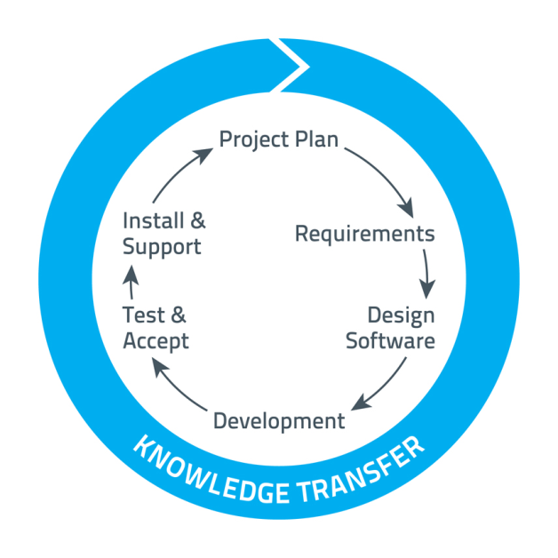
Figure 1- Knowledge Transfer Process

Technical Analysis-
Considering all the requirements and the features proposed, we agree on developing this site in-

Technology used while developing this system | Browser and OS Compatibility
- PHP 5.4x  - SQL Server 2008 (minimum) as discussed.  - HTML 5/CSS 3.0  - JavaScript  - JQuery  - AJAX  - Bootstrap 3.3 | - IE version 9,10,11  - Mozilla Firefox version 29 to 34 (latest)  - Google Chrome 30 to 40 (latest)  - Opera 9 to 26 (latest)  - Safari  For Mac OS X 5.0.6 onwards (latest)  For Windows 5.1 onwards (latest)  Operating System  - Windows XP, 7, 8.1  - Linux (Latest)  - Mac (Yosemite 10.10.1)
Table 1 Technology used and Browser compatibility

Minimum Server Requirements
- CPU: 2 Core
- RAM: 2 GB
- Disk Space: 120 GB
- Bandwidth: 1.5 TB
- IP Addresses: 2
- cPanel: Root Access
- OS

Table 2 Minimum Server Requirements

- HOW IT WORKS?

To understand the working of the system .Have a close view to the diagram below:

- LANDING PAGE (HOME)

In landing/home page is the most important page of the system as the user reaches this page first and then head onto others based on the navigation features and attributes present in the system.
Divide Home page in three sections, i.e.
Header

The header consists of following features and things
      - Scrolling page static menu bar
      - Static menu bar
      - Slider image or (banner)
The scrolling page static menu bar will have important menu options that will be easily used and will be static whenever the user scrolls the page.
- Employer Zone
Sub menu option (drop down)
      - Register here to find skills
      - Login here
      - Upgrade Membership
- Jobseeker Zone
Sub menu option (drop down)
      - Register here to be found
      - Login here
      - Upgrade membership
- Find Job
Sub menu option (drop down)
      - popular categories
      - Search by skill or title or City
- Find Resume
- Create a Job

The Static menu bar consists of following important options
- About us
- View all Blogs
- Pricings
Sub menu option
      - Employer pricing
      - Jobseeker pricing
- All categories/Industries
In slider image, there will 3 -5 slider images that will be sliding at a regular intervals and each slider has image that is admin manageable which upon clicking goes to concerned pages
      - There will be text written on the slider which can be edited with text effects of font ,font size and color
      - There will be button with its position fixed whose naming can be changed by admin for its admin own purpose (launching a event ,apply for a job fair ,etc)
- Do you want logos of renowned companies to be show as moving logos in a row below the slider image? Yes please. We need to be able to update this as we go.
- Do you want the slider to be sliding or immerging with fading in or fading out?Sliding.

Middle section

The middle section is also a crucial part of the system and consists of following sections
      - Find JOB ( an interactive search box whose functionality are discussed separately)
      - Find resume (an interactive search box whose functionality are discussed separately)
      - Testimonial box (here the system will show testimonials from both the users employers and jobseekers but not separate) these will be shown in a right hand side column.
      - Latest blog posts (these will be shown in array of two by two like large thumbnails )these thumbnails will have title ,image , 2 -3 lines description ,

Do you want video link to be shown here in the testimonials; videos can only from third party like YouTube, this is because a job fair can be introduced by video display as well?Sounds good. Limit this to a fancy add on and let’s get the operational basics correct first – I reckon a skype or similar link in to allow remote interviewing might be a good feature what are your thoughts?? No Skype

Footer

The footer will have CMS based content which help the user to know various rules and regulations; and other information,
These contents are for
      - About us
      - Terms and conditions
      - Contact Us,
      - Privacy Policy,
      - FAQ.
      - Post a Vacancy or Job

Do you want to include sitemap? Probably not needed.

- USER INTERFACES and ASSOCIATED USER ACTIONS

4.1 User Registration

As this is the site for the job portal, having a simple form filling won’t suffice so here we are including the registration page with various fields and these filled can be increased or decreased as per admin desire but all these fields will be fixed,(as it is required in the database table generation).

4.1.1. Jobseeker Registration Interface-
The jobseeker registration interface includes following basic fields to be filled.

Personal Details
      - First name
      - Middle Name
      - Last Name
      - Email Address
      - Date of Birth (MM/DD/YYYY)
      - Country Name (drop down menu and auto keyword selection)
      - Postcode or area code (valid postal code and area code confirmation)
      - Suburb (auto selects from the Suburbs table)

Employment Details
      - Status of employment (radio button option of currently employed ,looking for work, studying)
      - Country (drop down menu and auto keyword selection)
      - Home Address Line 1
      - Home Address Line 2
      - Years of experience (From ExperienceYears table)
      - Your Primary Industry (drop down menu and auto keyword selection)
Security
      - User Name (Alpha numeric)
      - Password
      - Confirm password
      - Enter Security Text from image (Captcha Code)

These are the basic fields that are mandatory to be filled and if the admin wants more field to be included then he needs to mention them before hand as later these fields can’t be changed due to database purpose. These additional fields will get added if it is enabled from backend.
Example: primary industry (sub primary industry) IT and IS > Software support
> Java developer
Business Analyst > data analyst
> Banking Finance Services and Insurance (BFSI)

Please provide all industry and categories list along with the list of each sub categories, also the set of skills that can be possible under each sub category or job. All these skills will be embedded into the database and then user can enter his skills which will be auto keyword based selection, If at all user wants to enter other skills he can make the description of it so.

For the time being, just use categories/sub-categories from Seek as an example. We need to be able to modify this list as we go though.

For the status selection I guess the following should be listed:
- Permanently Employed
- Part Time Employed
- Casually Employed
- Seeking Employment
- Student or vacation work
- Self Employed

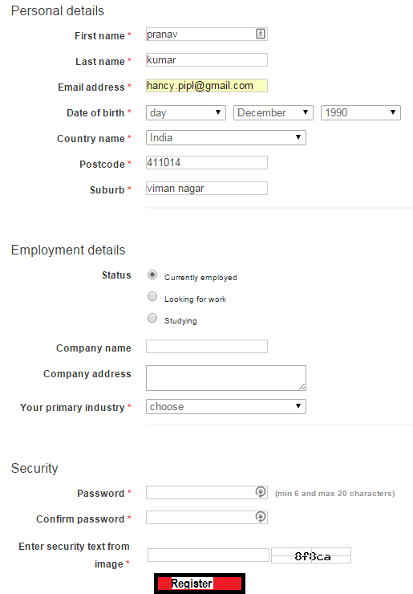

4.1.2. Employer Registration Interface

The Employer registration interface includes following basic fields to be filled.

EmployerName (company name)
Description
      - Primary industry

ABN/CAN
StreetAddress1
StreetAddress2
Suburb (auto select from the suburbs table)
Country (auto select from the Country table)

An employer can then have multiple logins

The EmployerLogin table includes the following fields…
Personal Details
      - First name
      - Last Name

      - Email Address

Security
      - User Name (Alpha numeric)
      - Password
      - Confirm password
      - Enter Security Text from image (Captcha Code)

The below screen shots will have to be altered to reflect a Company with multiple logins.
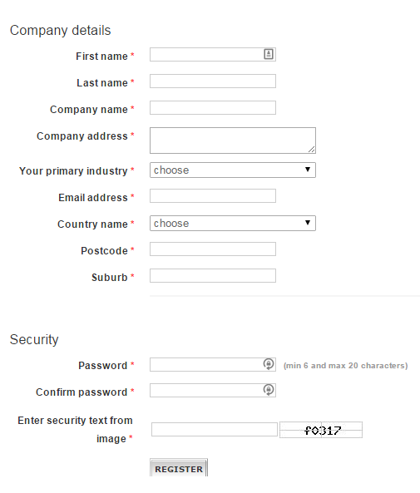

These are the basic fields that are mandatory to be filled and if the admin wants more field to be included then he needs to mention them before hand as later these fields can’t be changed due to database purpose.These additional fields will get added if it is enabled from backend.

Changes are listed above.

After this, the user has automatically agreed the terms and conditions, and is sent to login page where user is suppose to fill the credentials.
  - Login process

In login section user will be able to do logging in
Logging in for both kind of user has been explained below in common as both of them has same credentials to be filled

      - Username ‘,Or
      - Email id
      - Password
There will be “remember me” check box which will make the browser store the login information if logging is used later.

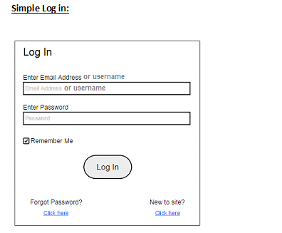
- In the simple login, the user has to Enter Email Address and Password
- The Remember me checkbox is provided so that the user credentials get saved an are remembered the next time when log in is attempted
- The user then clicks on the ‘Log in’ button to access the website.
There would be Forgot password and reset password links which will generate new password
Forgot Password:

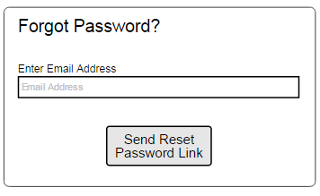
- In case the user forgets his password, he can click on the link below ‘Forgot Password’.
- He is then required to enter he Email Address with which he has registered into the app.
- A link is then sent on that particular email id from where he can reset his new password.
Note : for both users,Success takes user to the registered Home page. 5 failures within 15 minutes locks the account. Email is sent to site admin.

That’s fine.

  - Testimonials

Here the any user can see the testimonials which have been given by company employers and also by the job seekers who got an opportunity of job with this website. There will not be separate section for employers and jobseeker for testimonial display.

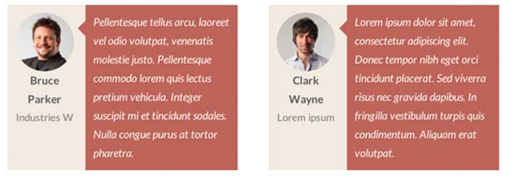

These testimonials will be 4 in a column and to view more testimonials user will click “view more” and this will make new testimonials to slide in and replace previous.

In each thumbnail display of testimonials there will be:
- Image of user
- Industry /company he serves.
- The user’s comment (this is admin manageable)

  - Latest Blogs

In the homepage middle section, there will be area of latest blogs of various events and announcements, the content and various media (pictures and videos, if present) will be managed by the admin. These latest blogs will be shown in rectangular format and the admin can also be able to manage the position of each in the latest blog section.
To make the user view more blogs posted earlier he will be sent to the page of events and announcements.

In the “events and announcements” user will see the entire previous blog posts list and after selecting a one user will be sent to the blog detail page. (Blog detail page is admin manageable)

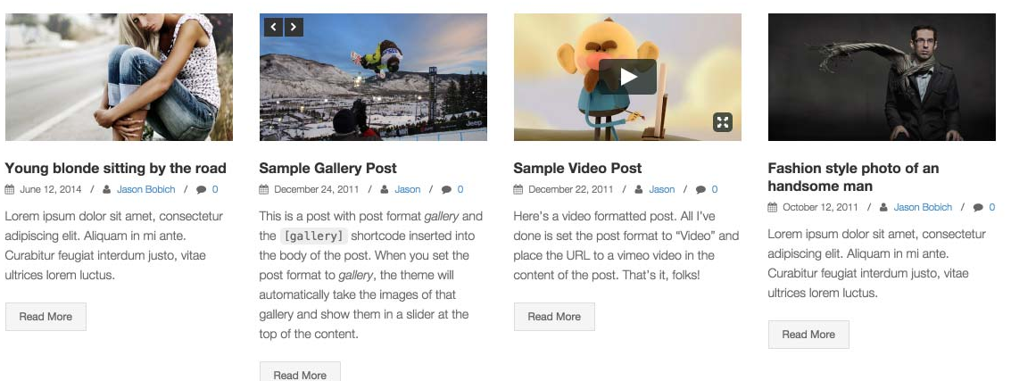

Do you want user to give comments, like and share the blog through social media?

Yes. We will also need to be able to moderate these. – They will need moderation prior to posting

  - Find Jobs
This is the feature which is for jobseekers and here a user can find job by selecting various fields. Employers only look at jobs that they have created so that they can maintain them (create new jobs, edit, delete or disable existing jobs.)
- Select country
- Select city
- Select zipcode
- Select job role – this should be a search string.
- Select industry
- Select functional area or sub category

There will be option of no location preference in that case, the country that has been selected will be taken into account and rest area information will be ignored and, according to that, jobs will be shown to the user.
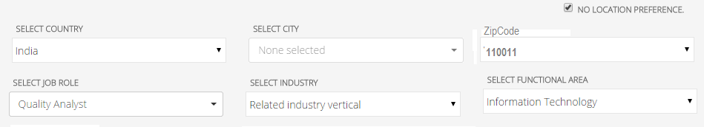

Note: we haven’t included suburb option while using the interface for finding the job , as it may make the system redundant ,if you want it please specify.

That’s fine.

After doing the submission the user will be sent to the jobs list page where user will see number of thumbnails relating to jobs which will be arrange in the order of time and date.

Each thumbnail of job will consist of following things
- Company name of company logo
- Date of post
- Title of the job post
- Experience required
- Location of work
- Number of positions This is fairly irrelevant as most job ads will be for one position. Please remove.
Each thumbnail information of job can be enlarged using “more” button which will lead to detail page of the job.

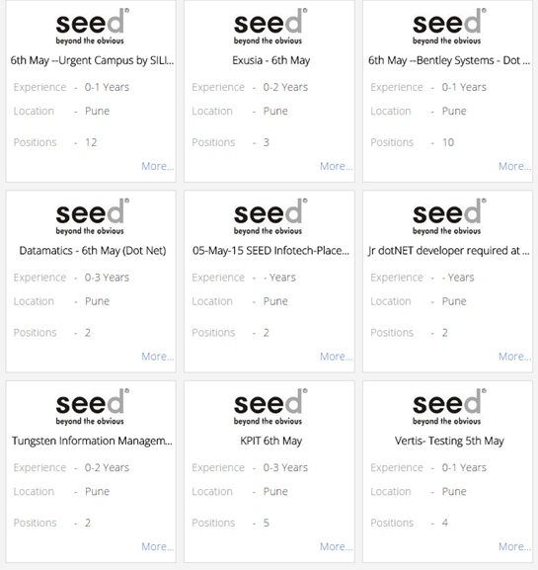

This is priority for visitor and employer user and when a registered jobseeker looks for job then he will see only those jobs posted by employers which his profile fits in and above. (Pertaining to skills and qualifications)

Note: the jobseeker can also use the below filters when use the site registered. Visitor can also see the search result but cannot be able to apply.

These listed jobs can be filtered using following filter agents
- Minimum experience and maximum experience
- Select company (auto-keyword selection)
- Select location (city zipcode and/or suburb)

  - Find resume

This feature is mainly for employers to help them in finding best resumes for his accounted posts and vacancies.

      - Select country
      - Select city
      - Select postcode
      - Select job role
      - Select industry
      - Select functional area or sub category
      - Skills / qualifications
      - Experience (minimum and/or maximum)

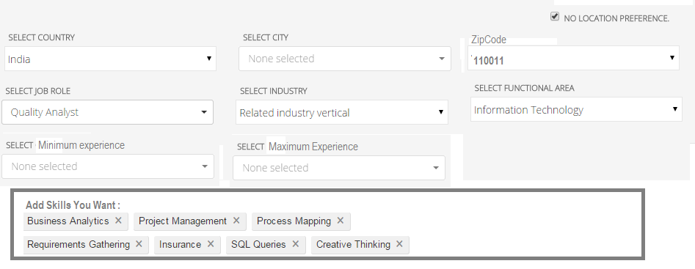

With submission of this employer will be able to find various resumes of jobseekers that are registered with the site and then can go to their profiles.

These resumes will be shown in terms of lists of thumbnails, each of which have
      - Image
      - Name
      - Experience along with companies he has served
      - Status of job
      - Profile Updated date

And after this employer will be able to see the detail profile page of the jobseeker. This should only happen with Employers who are paying their monthly fee.

  - Post a vacancy or job

This is feature that is available in the employer dashboard user can create a vacancy or job post here, the various elements that he needs to fill are
      - Title of job
      - Company name (left “ to be disclosed later” if user doesn’t want to show)
      - Industry (IT ,manufacture ,or else)
      - Functional area or sub category
      - Experience required
      - Country ,city ,postcode ,(auto selection keywords) ,suburb (if included)
      - Salary range (optional)
      - Number of posts – this is fairly irrelevant and can be removed.
      - Add skills required (auto selection keywords)
      - Job description
      - Employer Contact details – remove. Job seekers should only apply through the site.

To employer can launch the job created to get posted in the listing or can set a date or do manual launching of the saved jobs.
Note: can jobseeker be able to view the profile page of employer ?, if yes then we need to show his employment credibility and employing since when feature.

No… jobseekers should not be able to look at employer profile pages.

  - Apply for job.
When the job seeker profile is completed (basic fields) then he can do the application of on the job he has found .A user needs to be registered if he wants to apply for a job,while applying he needs to fill a simple form which consists of
      - Cover letter
      - Option to add current resume or update a new and then add. (thus previewing resume option will also be present)
Note : the resume will be uploaded in .docx file or. pdf file format only.

  - Pricing (and Pricing related information)

In this system pricing will be done on several issues, which have been discussed here
      - To take resume and contact information of jobseeker applications for a job.
      - To get resume and contact information of an individual job seeker
      - To upgrade account by getting membership (employer)
      - To upgrade account by getting membership (jobseeker)

- To take the resume and contact information of jobseekers who apply for a job.
To gain access to all information including contact details for job seekers who have applied for a job (this means anybody who has applied or may apply in future). It opens the job role for the employer to look at everyone who has applied. The employer must pay an amount of money (must be configurable).
- If a job seeker finds someone that they like the look of.
When the employer sees the profile from the “find resume functionality” or the “applied resumes” to his job post then , he can see the profile of the applicant or the job seeker, but not all information ,contact details and view and download resume of the jobseeker can only be done when the employer pays USD 100 for it. The amount must be configurable.

- To upgrade account by getting membership (jobseeker)
When upgraded to a membership account, the jobseeker will have advantage of showing his resumes on top in the find resume list page; the membership plan will be on monthly basis.

- To upgrade account by getting membership (employer)
When upgraded to a membership account, the employer will have advantage of showing his post job on top in the find jobs list page, the membership plan will be on monthly basis.

Note: please define a membership plan for both employer and jobseeker monthly basis.

Monthly only will be fine.

  - Detail page of JOB or Vacancy

This is the page which shows the details of the job or vacancy that has been posted by employer,
It consist of several sections
      - Job Title
      - Industry and subcategory
      - Location
      - Education required
      - Required skills
      - Supported skills
      - Job description
Along with user will be able to see the apply button, if the user is registered then user can see use the apply button but if the user is not registered the he needs to register first before applying.On the right hand side, the user can see their percentage match (skills, qualifications, experience). This will help them decide whether they should apply or not.

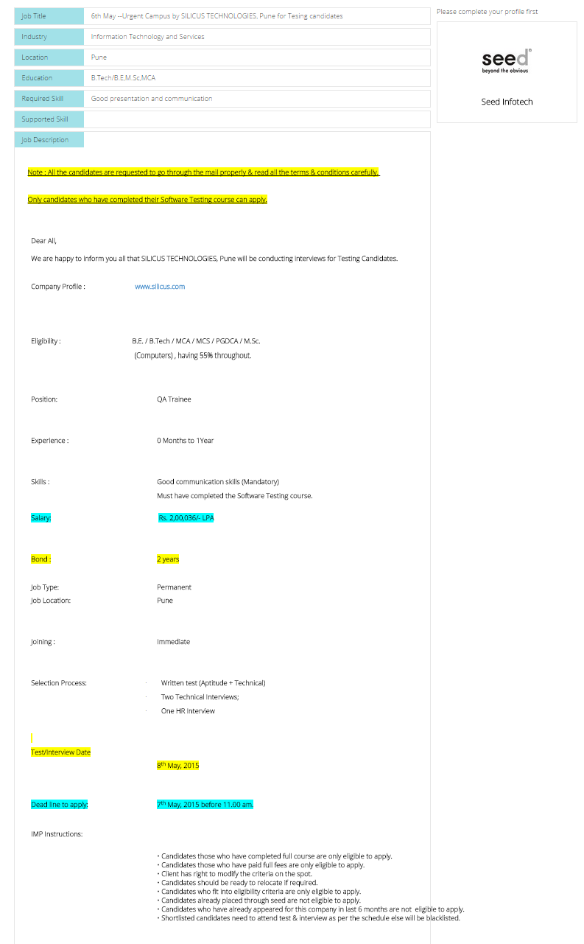

Bond can be removed.

- USER DASHBOARD

There will be two dashboards, one for employer and other for jobseeker /applicant.

5.1. Employer dashboard
Employer dashboard has following features
      - Profile
      - Profile settings
      - Jobs posted (edit or update post)
      - Applications. (with notification symbol on the title regarding number of new applicants applied)
      - Notifications (application received ,upgradation, payment done and others from admin)

Besides this employer will have option for posting a job.

General information that has been filled while registration will be stored in the dashboard and those information can be changed in profile setting.
      - Personal employer details
            - Image (upload an image representing company or employer .jpg format only)
            - Employer name, First name , Last Name
            - Email Address
            - Date of Birth (MM/DD/YYYY)
            - Country Name
            - Company name
            - Primary industry
            - Company address
            - Postcode or area code
            - Suburb
      - Security management
            - Username
            - Change password
            - Change email id

- Job posted ,It has the following things as shown in the table

Job post id | Job title | Status | Date of post launch | Applications received | Edit or update job | Make the job post premium
PPM99 | Business Analyst | Posted/  (it can be launch on 15 April/ or pending ) | 12 April ,15 | 30 | Button for editing or updating | Option for gaining membership to make this post for premium display

Note : from the status itself user can launch the job created which are pending to be launched ,this can be done manually or manually or change the date or prepone launch manually.

Sounds good.

Note : there will be filters as well for filtering out the jobs in the table
      - As per status (pending and launched)
      - As per date (latest or oldest first)
      - Searching as per title

Great.

      - Applications, here the employer can choose what profile details they want to have for which jobs.

Job post ID | Job title | Date of post /title creation | Applicants (name/date of birth)
PPM99,  If resume is selected directly from find resume then a NA will be shown | Business Analyst | 11 april,15 | Pranav ,16/2/1990  Shilpa ,12/2/1988  Amrut ,13/2/1987

In the applications, employer can see the limited (applicant or jobseeker) profile detail by clicking the name of the applicant ,and if the employer wants to see the detailed information of an applicant then he need to pay first onetime fee of USD 100 and then he can be allowed to see the completed details of the applicants whoso ever is applying.(even after the payment time)

The payment is around the job not the applicants. If you pay for a job to be opened, it means you will always be able to see the details of all applicants who apply for the job.

If the employer has seen a profile using “ find resume” feature then also ,to get the complete detail of the jobseeker he needs pay for it, before paying ,he can select for which jobseekers he likes and he wants to pay to view their profiles, this can be done by adding a name under a title (which shown in job title ) and then adding the job seekers into it .

That’s fine.

See the below steps that follows for finding resume by skills
      - Employer finds job seekers profile by using the feature “ find resume”
      - Employer sees the limited profile but In the limited profile display there is option of “add to view list”
      - By using “add to view list” , employer will add a title and add the job seeker to view list.
      - On next job seeker profile viewing and trying to add the profile into the view list he can automatically add the profile to the list.
      - On his desired number of addition he can now make the payment (USD 100) to view the detailed profiles of chosen jobseeker. (each title will have only one kind of job seekers having same industry and subcategory) Can you clarify this please?
      - He can add new profiles to view in the same view list title but to only 5 days from the date of creating title. No. Once a list of job seekers has been created and paid for, the employer can view these for up to 5 days. The employer cannot add to this list after it has been created and paid for.

Note : by each name shown under applicants ,the employer can see the description which the applicant has given while applying

That’s fine.

Note: we haven’t included the messaging system between employers and jobseeker as it is out of scope, if you want to include this messaging between jobseeker and employer then it may cost you more. Please specify

No… no messaging needed at this stage.

5.2. Job seeker dashboard and profile display

Job Seeker dashboard has following features
      - Profile
      - Profile settings
      - Jobs applied
      - notifications

General information that has been filled while registration will be stored in the dashboard and those information can be changed in profile setting.

      - Personal employer details

            - Image (upload recent image ,jpg format only)
            - First name
            - Last Name
            - Email Address
            - Date of Birth (MM/DD/YYYY)
            - Country Name (drop down menu and auto keyword selection)
            - Postcode or area code (valid postal code and area code confirmation)
            - Suburb

      - Employment Details
            - Status of employment (radio button option of currently employed ,looking for work, studying)
            - Country (drop down menu and auto keyword selection)
            - Company Address
            - Your Primary Industry (drop down menu and auto keyword selection)
      - Security
            - User Name (Alpha numeric)
            - Password
            - Confirm password

Country

Visa type

Valid till
      - Education
This will involve filling the list
            - College /school/trade school
            - University
            - From
            - To
            - Type (graduation, diploma, ,Post graduate ,others)
            - Degree (B .A ,B.tech, B.archetc)
            - Specialization
            - Average Percentage or score

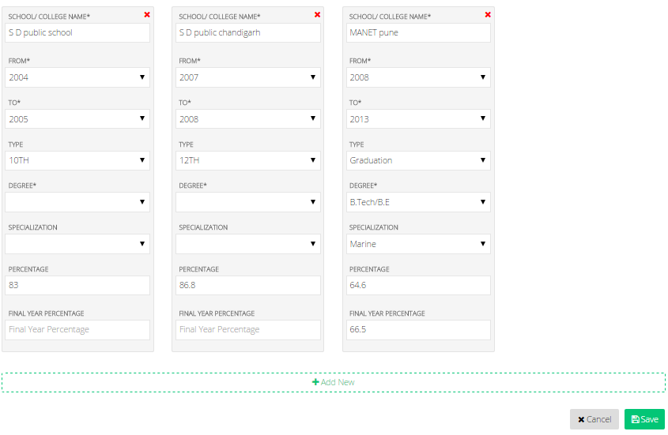
      - Skills
            - Skills the jobseeker possess ( update skills via crossing and adding new)
            - Add new skills(this will be auto- keyword selection of various skills and the saved skills will be added to his dashboard )

Note : on clicking the cross option on any of the skills that has been added ,that skill will get out
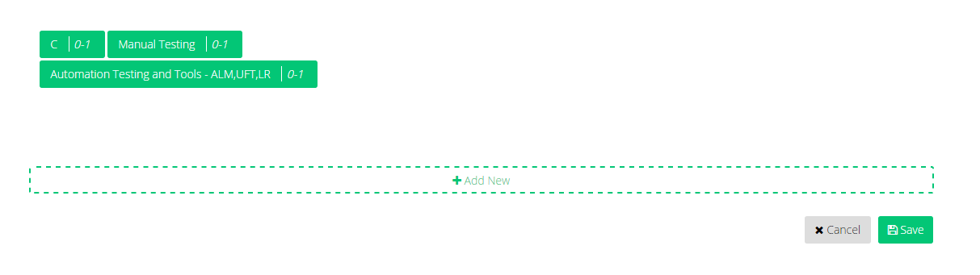
      - Professional info ,professional info consists of following things
            - I am a fresher ,or
            - Company name ,location address, job title, experience (month and years).
      - Accreditations or certificates
            - Here the user can add the accreditations or certificates by uploading them in pdf or jpg format.
            - He can make updation by deleting previous ones and adding new
            - These certificates and accreditations will be listed in number and file names with small image display of them. And to view in big he make use of preview.
      - Resume or Curriculum Vitae
            - Here the user can add the accreditations resume by uploading them in pdf or MS word doc format.
            - He can make updation by deleting previous one and adding new
            - Small image display of it will be displayed. And to view in big he make use of preview.
      - Hobbies
            - List of various hobbies he possesses.

- Jobs applied
Here the user will see the list of jobs that he has applied
Company name and employer name | Date of job posted and date of application | Status of application
 |  | (response pending, accepted)

Sorting can be done by oldest or latest applied.

Here we need to get smart – if a paid member has a premium advantage over a non paid member I would like to see this summary for a paid member to visualize the following:

- Jobs applied for
- Employers who downloaded resume or resume download count
- Number of ads qualifications got matched for and presented to employers
- Etc.

Not included

- Notifications
Notifications will be like short message which will tell In short what it is for
      - Application selected
      - New job posted (with same industry, sub category and primary skills)
      - Admin notifications regarding (successful upgradation ,payment and others)

Job seeker profile view(Limited )
The various thing which an employer (or visitor will see) in the job seeker profile are :
      - Image
      - Name
      - Job status
      - His industry and current job title
      - Companies he served which time of experience in each (current and previous two separate section)
      - Current city and state he is in.
      - Highest education qualification.
      - Passport (yes /no)

button to “ add to view list”

- PAYMENT SYSTEM AND FLOW

PayPal is the only which is being used for collecting payment and the payment system is direct payment system where ,when a user makes a payment then after deduction of any commission the payment goes to the client or admins PayPal account.

The employer will pay for membership or profile views of jobseekers and after deduction of paymentgateway commission, the amount will directly go to the admins account.
The jobseeker will also pay for membership and after deduction of payment gateway commission , the amount will directly go to the admins account.

Note: please define the membership terms and features like the job seeker profile will be at the top for 4 weeks if the membership is for 1 month.

I believe that this has already been done above. Membership will roll for one month at a time. If you paid on April 3, your membership would expire on May 2.

- ADMIN PANEL

Global setting
- Website details- website name, title and URL
- Website logo change facility
- Admin email address
- Contact us mail
- Contact us phone number-
- Latest blog management and blog list management.
- Banner or slider management

Admin/User management
- Create admin users
- Delete user
- Edit users details
- Manage user(Active/inactive)
- Search user
Category Managements:
From here the admin can manage the various categories ,sub categories and also various skills that he thinks should be added to the database.

Financial Management :
The various payment occured can be viewed here in the form of table :

Jobpost ID | Job title | Date of post or création | Payment status (USD 100)

Also there will be table showing the profiles which has been upgraded to premium membership

Note : from here itself he can change the membership price value month or week wise for each user and also he can change the price for viewing the detail profiles by employers.

Sounds good

Email Template management :
- In this section user can manage template for email. Email template for password recovery, for order confirmation.
- There are a number of auto-generated emails that are generated when user signs up, starts a FR campaign, when a donor donates, when donor contacts organizer, organizer gets updated email each time a donor donates.
Manage featured elements
- Featured image in slider (and associated links and link to shop now in the slider)
- Featured product in middle section and associated link.
- Featured images in middle section (all images including slider 1 and 2)
- Old blogs title display and link.

Email management
Here admin can select the particular type of users and send them generic email as per requirements

CMS Management:
- Content of CMS pages can be managed from this section. (Layout/Design will remain same)
- Here user should be able to manage the title, tag for each page.
The various CMS sections are
- Testimonials
- Blogs
- About us
- Terms and conditions
- Contact Us,
- Privacy Policy,
- FAQ.
Manage reports:
Reports to be generated from backend:
    - Revenue generated
    - Monthly
    - Yearly

