Negotiation Module: P964

Client's Initial Requirement:

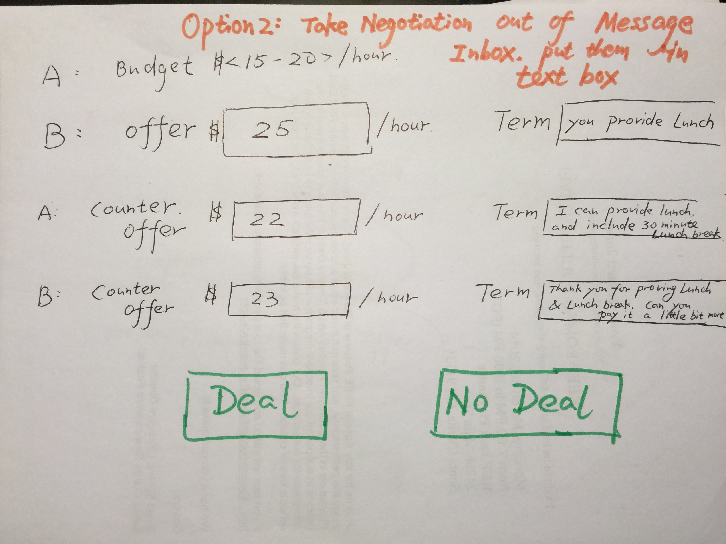

Proposed Solution/Functional Flow:

When any project has been posted by any employer(Say A) with Project Hourly Rate says $15-20 per hours. Then Service provider(Say B) will bid on it. So bidded amount SP has sent is $25

So, Now all bidded amount request will be listed down over here:-

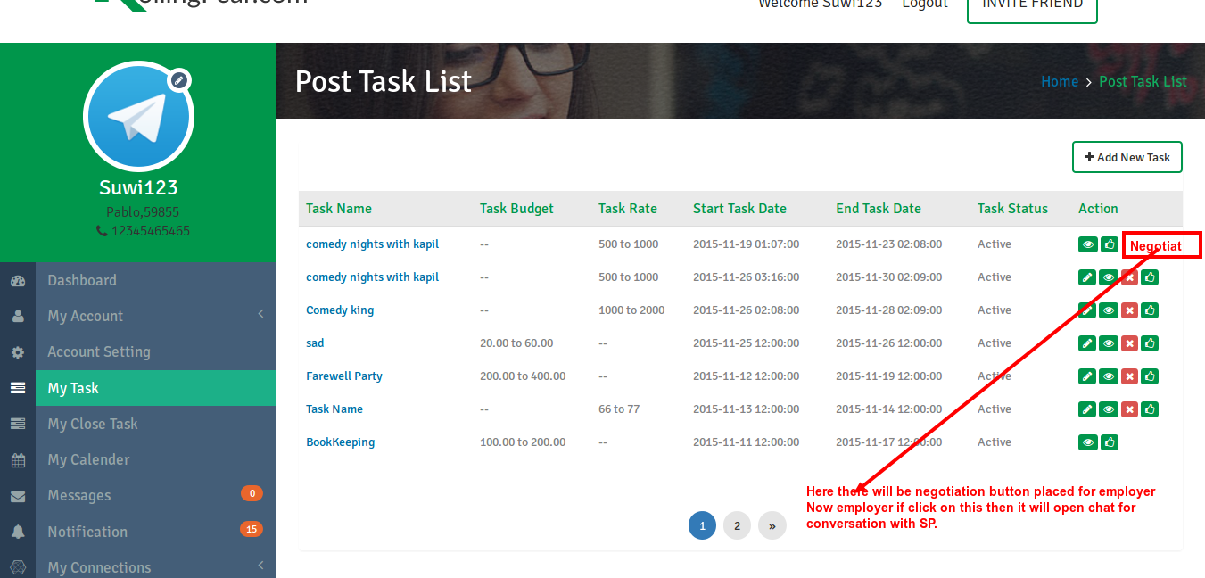
Now if employer wants to Negotiate with the bidded amount then he/she will click on “Negoriate” button which will open chat window for conversation with bidder(SP).

Now these are the following further steps:-

- Normal chat will be going on for deciding the project amount between A & B.
- If both are mutually agreed then B(SP) will send his negotiation proposal via form.
- Here on chat, there will be option called “Send Deal” if B wants to send Deal to A(Employer) then B will fillup these fields in popup:-
a. Choose Project (Dropdown)
b. Amount (Text box)
c. Terms (textarea)
d. “Send” button
- After filled up these details then if B press this on Chat then these details will be posted on that conversation along with these two button “Deal” or “No Deal”.
- Now after getting negotiated amount, if A is interested then A needs to press “Deal” button and one confirmation popup will be appeared saying “Are you sure?.....” If he press ok then project will be assigned and notification will be sent to B that he has been accepted/assign for this project.
- If A click on 'No Deal” button then again popup will be open for re-entering new Negotiation amount.

Once porject will be assigned then normal current project flow will be applicable.

