Here is the order being placed by [truptigondaliya@yahoo.com](mailto:truptigondaliya@yahoo.com) who has earned $5 credit as the referrred friend has made a purchace. However this order doesn't show that credit here:  
  
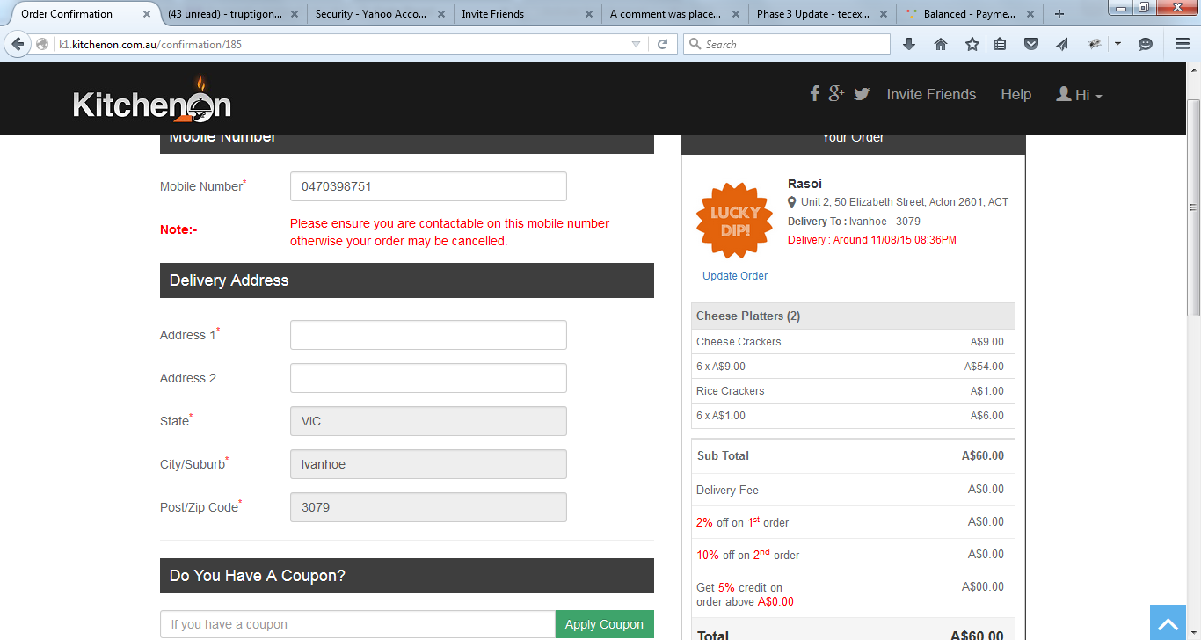

Regards,

Can you please provide info on this:  
  
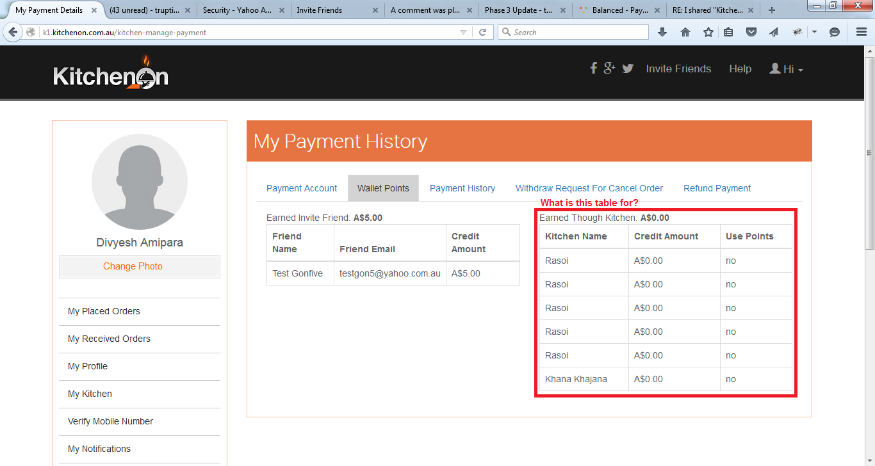

Regards,