Hi. Please find out feed back for the quotation pages:
As you know in the shipping business: for each item to be shipped there are different information’s needed to be collected from customers in order to offer for them more precise quote.
For that I suggest we follow the same forms used by uship.com as you can see bellow:
1- Category name: Household Goods : Quote form link:
https://www.uship.com/listing2.aspx?c=14&z1=dubao&country1ID=1&z2=dklk&country2ID=1&w=&r=
2- Category name: Household & Office Moves / Sub category: Small Studio - Large Studio or 1 BR Apartment - Large Studio or 1 BR Apartment - 2 BR Apt -3 BR House - 4 BR House - 5+ BR House - Mobile Homes -Tradeshow Equipment- : Quote form Link
https://www.uship.com/listing2.aspx?c=69&z1=dubao&country1ID=1&z2=dklk&country2ID=1&w=&r=
Sub category : Office : Quote form link:
https://www.uship.com/listing2.aspx?c=74&z1=dubao&country1ID=1&z2=dklk&country2ID=1&w=&r=
Sub category: Other Household & Office Moves : Quote form link:
https://www.uship.com/listing2.aspx?c=78&z1=dubao&country1ID=1&z2=dklk&country2ID=1&w=&r=
3- Category: Vehicles : Sub category: Cars & Light Trucks \
With the information’s collected from the home page like Make – Model – Quantity - Please add fields for : Vehicle value for Insurance ( currency and value) – Vehicle Running ( yes or no)– Choose shipment method : (Land Transport – Roro Vessel – Container – Airplane or Cheapest) - upload photo(option) – Any special instructions . Date of shipment – Date of arrival.
Sub Category: Trailers - Trailer Homes: Quote form link:https://www.uship.com/listing2.aspx?c=82&z1=dubao&country1ID=1&z2=dklk&country2ID=1&w=&r=
Sub Category: Vehicle Parts: Quote form
https://www.uship.com/listing2.aspx?c=84&z1=dubao&country1ID=1&z2=dklk&country2ID=1&w=&r=
Sub Category: Antique Vehicles - Other Vehicles : Quote form
https://www.uship.com/listing2.aspx?c=87&z1=dubao&country1ID=1&z2=dklk&country2ID=1&w=&r=
Sub Category: Heavy Trucks & Construction Vehicles Quote form
https://www.uship.com/listing2.aspx?c=88&z1=dubao&country1ID=1&z2=dklk&country2ID=1&w=&r=
4- Category : Motorcycles & Power Sports
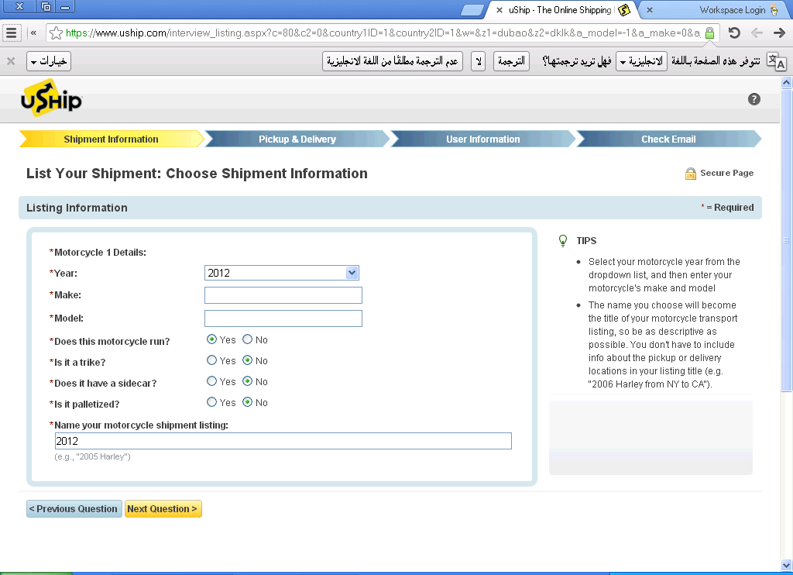
Sub category: All Terrain Vehicles
https://www.uship.com/listing2.aspx?c=86&z1=dubai&country1ID=1&z2=sharjah&country2ID=1&w=&r=
Sub category: Go Carts & Dune Buggies - Other Power Sports
https://www.uship.com/listing2.aspx?c=89&z1=dubai&country1ID=1&z2=sharjah&country2ID=1&w=&r=
5- Category: Boats
Subcategory: Power Boats - Personal Watercraft - Other Boats https://www.uship.com/listing2.aspx?c=95&z1=dubai&country1ID=1&z2=sharjah&country2ID=1&w=&r=
Note: Please add the following Q: Is your boat loaded on trailer ( yes or No ) Q – What is the value for insurance ?
Subcategory: Boat parts
https://www.uship.com/listing2.aspx?c=96&z1=dubai&country1ID=1&z2=sharjah&country2ID=1&w=&r=
6- Category: Heavy Equipment
https://www.uship.com/listing2.aspx?c=391&z1=dubai&country1ID=1&z2=sharjah&country2ID=1&w=&r=
7- Category: Less than truck load freight 8- Full Truckload Freight use the same form for both
https://www.uship.com/listing2.aspx?c=132&z1=dubai&country1ID=1&z2=sharjah&country2ID=1&w=&r=
9-- Category: Business & Industrial Goods ( for all sub category)
Subcategory: form link:
https://www.uship.com/listing2.aspx?c=24&z1=sha&country1ID=1&z2=DKJ&country2ID=1&w=&r=

10- Category: Special Care Items for all subcategory
https://www.uship.com/listing2.aspx?c=114&z1=sha&country1ID=1&z2=DKJ&country2ID=1&w=&r=
11- category: Food & Agricultural Goods for all subcategory
https://www.uship.com/listing2.aspx?c=103&z1=dubai&country1ID=1&z2=sharjah&country2ID=1&w=&r=
12- Small Packages:
https://www.uship.com/listing2.aspx?c=415&z1=dubai&country1ID=1&z2=sharjah&country2ID=1&w=&r=
13- passengers
Fill form about: Q- How many passengers Q- Ages – Q – Male – Female – Children
Q- Trip From Q- Trip to destination Q- One way or two way trip Q- Waiting period
Add additional details box.

Note: at the end of each form above please link the following Pick up and delivery form
https://www.uship.com/listing2.aspx?c=415&z1=dubai&country1ID=1&z2=sharjah&country2ID=1&w=&r=

